
Survey Report

FPGA-Based 3×3 Convolution Engine for Image Processing

Subject: FAP201

No | Name | Student ID
1 | Phạm Minh Tùng | SE204386
2 | Mai Đình Tuấn | SE204186
3 | Trần Tuấn Lâm | SE194892
4 | Bùi Lê Văn Khoa | SE203529

May, 2026
- INTRODUCTION
1.1 Problem Statements
Nowadays, Image processing plays a crucial role in many modern fields such as AI, autonomous vehicles, security surveillance, and medical imaging. Many image processing algorithms utilize convolution, particularly in applications such as edge detection, image blurring, and convolutional neural networks (CNN).
However, in computer vision and artificial intelligence (CNN) systems, convolution accounts for over 80% of the computational load. For real-time video processing applications, traditional sequential processors (CPUs) often experience bottlenecks due to having to perform millions of repetitive calculations. CPU-based convolutional processing is often limited in speed and latency when processing image data in real time. FPGAs (Field-Programmable Gate Arrays) are a suitable solution thanks to their parallel processing capabilities, low latency, and hardware reconfigurability.

- This study focuses on 3x3 convolutional architectures on FPGAs for image processing. The content includes convolution principles, line buffers, sliding window generators, MAC engines, and implementation architectures such as serial, parallel, and synchronous arrays.
1.2 Why Choose FPGA For This Problem ?
FPGAs (Field-Programmable Gate Arrays) possess a configurable parallel hardware architecture, enabling:
- Full Parallelism: Simultaneously performing multiple multiplication-addition (MAC) operations in the same clock cycle.
- Pipelining: Breaking down computation tasks to increase the system's operating frequency (Fmax), allowing for continuous streaming of pixel data without waiting for the previous pixel to finish processing.

- FUNDAMENTALS OF IMAGE CONVOLUTION
2.1 Digital image representation
Grayscale images can be represented as a two-dimensional matrix, where each element represents the brightness of a pixel with a value from 0 to 255.

For example, the image below:
- 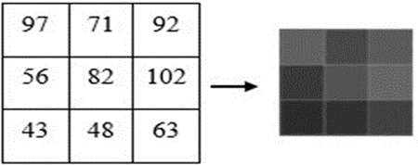

Each value corresponds to the brightness of a pixel.
2.2 Convolution Operation
- Concepts of the Model
Filter/Kernel: A filter, also known as a kernel, is a small matrix used to transform input data by sliding on it. Typically, filters are 3x3, 5x5, etc. in size. Each filter detects a specific feature, such as edge, corner, or texture. Typical filters include Sobel, Sharpening, Blur, etc.

Stride: Refers to the number of pixels the filter moves on the input data. A stride of 1 means the filter moves one pixel at a time, while a stride of 2 means it moves two pixels at a time.

Padding: Involves adding extra pixels around the edges of the input image. This ensures that the filter matches correctly as it slides on the edges of the image. Common padding types are ‘valid’ (no padding) and ‘same’ (padding to keep the output size the same as the input).

Activation function: After the convolution operation, an activation function such as ReLU (Rectified Linear Unit) is applied to introduce nonlinearity into the model. ReLU replaces all negative pixel values ​​in the feature map with 0, increasing computational efficiency and minimizing gradient decay.
- Convolution is an operation in which a small matrix called a kernel or filter slides over the input image to perform multiplication and addition.
General formula:

$y(i, j) = \sum_{0}^{2}{}\sum_{0}^{2}{}x(i+m,j+n).w(m,n)$
- where:
$x(i+m,j+n)$: pixels of the input image.
$w(m,n):$ kernel/filter value.
$y(i, j):$ output pixel after convolution.

- Example: Convolution Operation with a 3×3 filter on a 5×5 input image.
Input image:
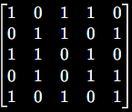
Let's assume we're using a Sobel-like Kernel :
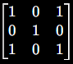
Convolution operation:
- First 3x3 Window (top-left corner)
Input submatrix:
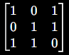
Element-wise multiplication with filter ( convolution):
(1*1) + (0*0) + (1*1) + (0*0) + (1*1) + (1*0) + (1*1) + (1*0) + (0*1) = 4

First pixel output: y(0,0) = 4
- Second 3x3 Window ( move filter one stride to the right):
Input submatrix:
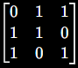
Element-wise multiplication with filter ( convolution):
(0*1) + (1*0) + (1*1) + (1*0) + (1*1) + (0*0) + (1*1) + (0*1) + (1*1) = 4

First pixel output: y(0,1) = 4

- The filter will continue to slide across the entire input image. The resulting feature map (the result of the convolution operation) will look like this:

Feature map:
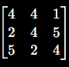

- From the example above, it can be seen that convolution works by having the 3x3 kernel sequentially slide over the input image. At each location, the system performs a multiplication between the pixels in the window and the kernel weights, then adds the entire result to create an output pixel.

- This feature map represents the features detected by the kernel from the input image. Larger values ​​indicate areas of the image with a high degree of similarity to the kernel, while smaller values ​​indicate a lower degree of similarity.

2.3 Survey of Filters and Applications
In traditional image processing, the Kernel coefficients (K) are fixed. The research team investigated typical filters:

Sharpening Kernel
The sharpening kernel is designed to enhance the edges and details in an image, making the image appear clearer and more defined. It works by amplifying the differences in pixel intensity.
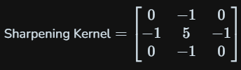

Applying this kernel to an image increases the contrast around edges, making them more pronounced.

Gaussian Blur Kernel
The Gaussian blur kernel is used to reduce image noise and detail by averaging the pixel values ​​with a weighted Gaussian distribution. This kernel is useful for creating a smooth, blurred effect that minimizes the high-frequency noise in the image.
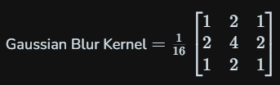

This kernel assigns higher weights to the central pixels and progressively lower weights to the surrounding pixels, resulting in a more natural blur.

Sobel Kernels
This kernel assigns higher weights to the central pixels and progressively lower weights to the surrounding pixels, resulting in a more natural blur.
- Sobel Kernel (Horizontal)
This kernel detects horizontal edges by emphasizing vertical gradients.
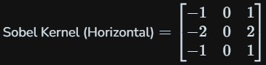

- Sobel Kernel (Vertical)
This kernel detects vertical edges by emphasizing horizontal gradients.
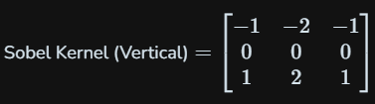

Laplacian Kernel
The Laplacian kernel is a second-order derivative operator used for edge detection. It highlights regions of rapid intensity change and is particularly useful for finding edges in noisy images.
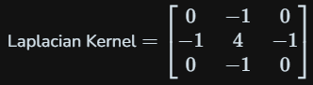
This kernel calculates the second derivative of the image, providing a precise way to detect edges by highlighting areas where the intensity changes rapidly.

III. SURVEY AND SELECTION OF MAC COMPUTING ARCHITECTURE

The problem: After obtaining 9 parallel pixels from the slide memory location, how do we perform 9 multiplications and 8 additions? This research examines three architectures:

- Serial MAC Architecture

- Serial MAC is the simplest architecture in FPGA convolution. In this architecture, the system uses a small number of multipliers and performs convolution over many clock cycles.
- Operating principle: Instead of performing the entire multiplication at once:
- a multiplier will be reused multiple times
- each element of the window will be multiplied by the kernel in turn.

- Parallel Adder-Tree MAC Architecture

- Parallel MAC is the most common architecture for high-speed convolutional FPGAs. In this architecture, all multiplication is performed concurrently; each multiplier processes one element of the kernel.
- Operating principle: With 3x3 convolution:
- 9 multipliers are needed.
- All operate in parallel.
- The adder tree adds up all the results.
- This produces pixel output almost every clock cycle.

- Systolic Array Architecture

- Systolic Array is a highly parallel architecture commonly used in modern AI accelerators and CNN accelerators. This architecture consists of multiple Processing Elements (PEs) connected in a pipeline matrix.
- Processing Element: Each (PE) performs the following tasks: multiplying the data by the weight, adding the accumulator, and passing the data to the next PE.

- For examples: PE = Multiplier + Adder + Register
- Operating principle: Data and kernel will continuously move through the PEs like a stream. Each clock the PE performs a MAC and transmits the partial sum to the next PE.

IV. CURRENT TREND
Currently, convolutional research on FPGAs focuses on:
- Increasing processing speed using Parallel MAC and Systolic Arrays.
- Optimizing pipelines to increase throughput.
- Reducing memory access using line buffers and data reuse.
- Using fixed-point and quantization to reduce FPGA resources.
- Developing CNN/AI accelerators for edge AI and real-time image processing.

V. CONCLUSION
Convolutional architectures on FPGAs enable high-speed image processing with low latency thanks to their parallel processing capabilities. Serial MACs are suitable for small, resource-efficient systems, while Parallel MACs, Pipeline, and Systolic Arrays are ideal for real-time image processing and AI acceleration. Techniques such as line buffering, sliding window, pipelining, and data reuse optimize the performance of convolutional systems. With the development of AI and Computer Vision, FPGAs continue to be a crucial platform for modern image processing and CNN acceleration applications.

